**Year 12 Assessment Template – Creating a database-driven website – AS91892/3**

## Stage 1 – Relevant implications and conventions

Relevant implication 1:

Privacy: My website will have a login function so I will have to make sure the users passwords are encrypted within the database to protect the user.

Relevant implication 2:

Functionality: ill need to make sure my labels are correct and the link between the two tables are functional as it is vital in the user being able to upload their tracks.

Web design conventions:

Some of my code is bootstrap and I am using CSS to change the aesthetic of the site. Ill need to add comments and appropriately name my files to avoid confusion or errors. All function code will be php and html.

## Stage 2 – Establishing design of site and database and relevant implications

Site design:

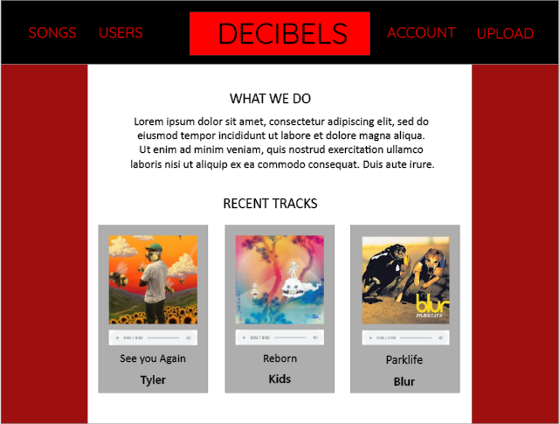

Database design:

|  |  |  |  |
| --- | --- | --- | --- |
| Table name: | Music | | |
| Column names | Data type | Length | Comment(s) |
| coverArt | VARCHAR | 500 |  |
| AudioFile | VARCHAR | 500 |  |
| songName | VARCHAR | 30 |  |
| musicID | INT | 3 | PRIMARY, AUTO_INC |
| review | userID | 3 | Linked to users database |

|  |  |  |  |
| --- | --- | --- | --- |
| Table name: | Genres | | |
| Column names | Data type | Length | Comment(s) |
| Username | VARCHAR | 30 |  |
| Password | VARCHAR | 100 | encrypted |
| userID | INT | 3 | PRIMARY, AUTO INC, kinked to another table |
|  |  |  |  |
|  |  |  |  |

(Add more tables if necessary)

Justification of database design:

The user will have to be logged in to use the upload feature of the website, this means that any uploaded track will be linked to the user and their account registered to the users table will be linked to their song in the music table through the UserID tag.

## Stage 3 – Ongoing testing and development

Date: 05/06/2020

Student name: Tyler Clink

Feedback: the site said uploaded but the content was not added to the database or files, this was due to the files name being too long as it included a YouTube link in it

Changes made as a result of feedback: I added more leniency, or the number of characters allowed from 30 to 300 and increased the allowed file size by 5 megabytes.

Date: 07-06-20

Student name: Hugo Mclachlan

Feedback: delete function errors and breaks the site, when I put a user in with ths same username it adds them

Changes made as a result of feedback: I did some error catching to prevent people adding usernames already in the database and fixed the delete section.

Date: 09-06-20

Student name: Sean Marriot

Feedback: There was not really any issues that I found the test was good and functional.

Changes made as a result of feedback:

Date:

Student name:

Feedback:

Changes made as a result of feedback:

## Stage 4 – Final evaluation

Relevant implications:

The login feature is functional and very vital for how my site functions. The user can create an account and login which gives them access to the upload feature and the ability to delete their own tracks, they can also logout if they choose.

The website encrypts any password entered before adding it to the database, there is no way of checking the user’s password from anywhere on the site or database.

End-user requirements:

The tables are linked and users can add and delete items.